CFI-S App Manual

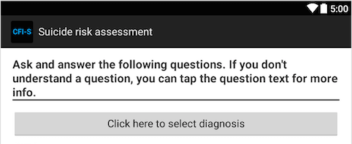 | - Tap this button to select diagnosis from a pop-up menu.  - Choices:  - Bipolar  - Depression  - Schizoaffective Disorder  - Schizophrenia  - Other  - Lack of response counts your diagnosis as missing and categorizes you as “No Psychiatric Diagnosis”  - Note: answer does not affect CFI –S score but is used to assess how the participant’s score compares to the scores of other people in the same diagnostic group.
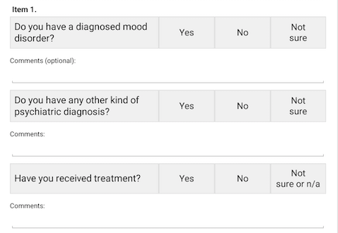 | - A Yes answer to the first and/or the second question gives you 1 point, for a maximum of 1 point.  - A No answer to both questions gives you 0 points.  - If the participant answers neither question or indicates Not Sure for both, their answer for this Item is counted as NA.  - The third question does not currently affect scoring but the participant’s answer is saved as supplementary information.
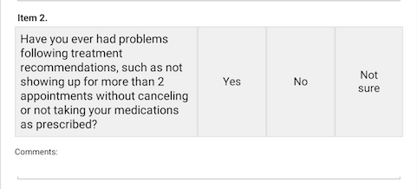 | - A Yes answer gives 1 point  - A No answer gives 0 points  - Lack of response or ‘Not sure’ responses are counted as NA.
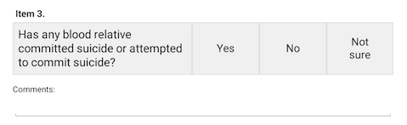 | - A Yes answer gives 1 point  - A No answer gives 0 points  - Lack of response or ‘Not sure’ responses are counted as NA.
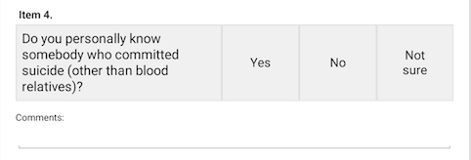 | - A Yes answer gives 1 point  - A No answer gives 0 points  - Lack of response or ‘Not sure’ responses are counted as NA.
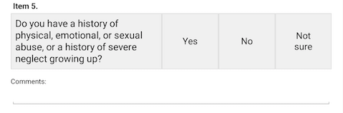 | - A Yes answer gives 1 point  - A No answer gives 0 points  - Lack of response or ‘Not sure’ responses are counted as NA.
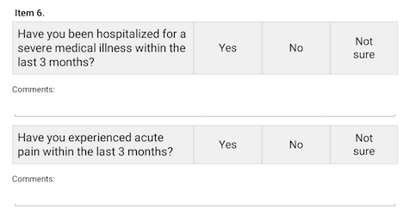 | - A Yes answer to the first and/or the second question gives you 1 point, for a maximum of 1 point.  - A No answer to both questions gives you 0 points.  - If the participant answers neither question or indicates Not Sure for both, their answer for this Item is counted as NA.
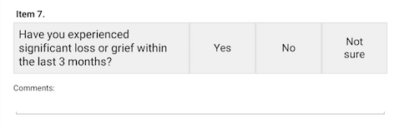 | - A Yes answer gives 1 point  - A No answer gives 0 points  - Lack of response or ‘Not sure’ responses are counted as NA.
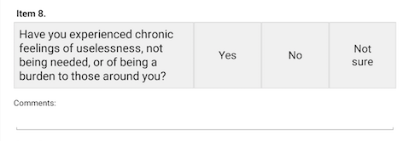 | - A Yes answer gives 1 point  - A No answer gives 0 points  - Lack of response or ‘Not sure’ responses are counted as NA.
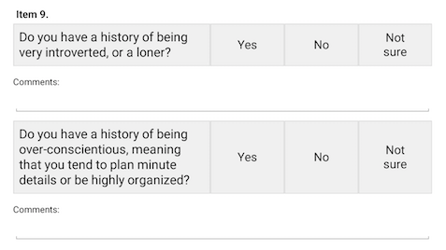 | - A Yes answer to the first and/or the second question gives you 1 point, for a maximum of 1 point.  - A No answer to both questions gives you 0 points.  - If the participant answers neither question or indicates Not Sure for both, their answer for this Item is counted as NA.
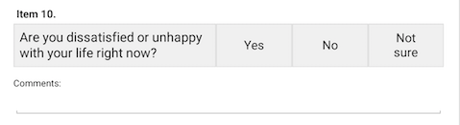 | - A Yes answer gives 1 point  - A No answer gives 0 points  - Lack of response or ‘Not sure’ responses are counted as NA.
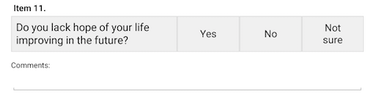 | - A Yes answer gives 1 point  - A No answer gives 0 points  - Lack of response or ‘Not sure’ responses are counted as NA.
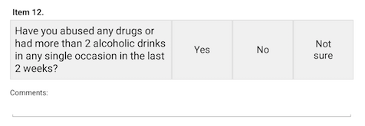 | - A Yes answer gives 1 point  - A No answer gives 0 points  - Lack of response or ‘Not sure’ responses are counted as NA.
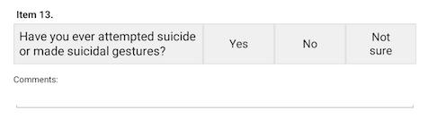 | - A Yes answer gives 1 point  - A No answer gives 0 points  - Lack of response or ‘Not sure’ responses are counted as NA.
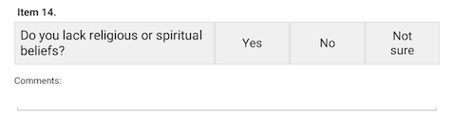 | - A Yes answer gives 1 point  - A No answer gives 0 points  - Lack of response or ‘Not sure’ responses are counted as NA.
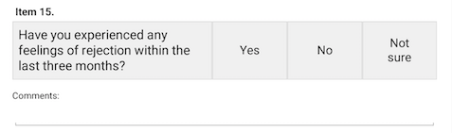 | - A Yes answer gives 1 point  - A No answer gives 0 points  - Lack of response or ‘Not sure’ responses are counted as NA.
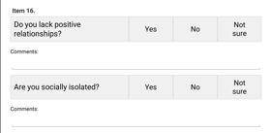 | - A Yes answer to the first and/or the second question gives you 1 point, for a maximum of 1 point.  - A No answer to both questions gives you 0 points.  - If the participant answers neither question or indicates Not Sure for both, their answer for this Item is counted as NA.
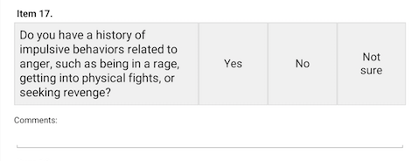 | - A Yes answer gives 1 point  - A No answer gives 0 points  - Lack of response or ‘Not sure’ responses are counted as NA.
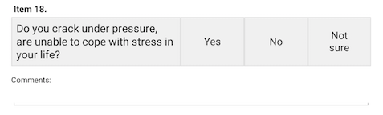 | - A Yes answer gives 1 point  - A No answer gives 0 points  - Lack of response or ‘Not sure’ responses are counted as NA.
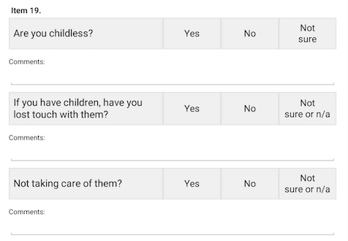 | - A Yes answer to the first question gives you a point of 1 on this Item.  - A No answer gives you 0 points.  - Item is counted as NA if the participant answers ‘Not sure’ to the first question or does not respond to it  - Answers to the second and third question do not currently affect overall scoring but are saved as supplementary information
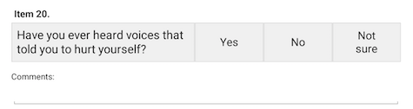 | - A Yes answer gives 1 point  - A No answer gives 0 points  - Lack of response or ‘Not sure’ responses are counted as NA.
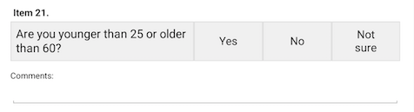 | - A Yes answer gives 1 point  - A No answer gives 0 points  - Lack of response or ‘Not sure’ responses are counted as NA.
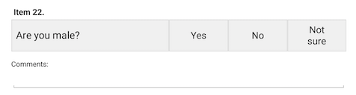 | - A Yes answer gives 1 point  - A No answer gives 0 points  - Lack of response or ‘Not sure’ responses are counted as NA.
Final score is calculated as the total number of accumulated points divided by the total possible points that the participant could have received not counting the NA responses.

For example, if the participant answers 16 of the above questions and accumulates 4 points in the process, their final score on the CFI-S is 0.25.

The “percentile” output indicates what percent out of the maximum score recorded to date for that diagnostic group.

Note: For the CFI-S version code, numbers left of the decimal indicate major changes, such as adding or removing an item. Numbers to the right of the decimal indicate minor changes, such as updating the reference database.

